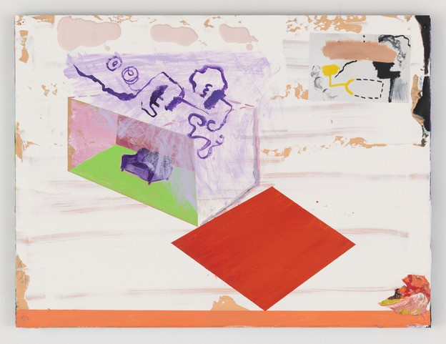
Walter Price, Don’t let the clouds steal your color. Courtesy of the Artist, Green Naftali, New York and The Modern Institute/Toby Webster Ltd., Glasgow
Guidance Notes for Applicants
These notes are intended to help you to participate in our selection process as effectively as possible and assist you in providing us with all the information that we need to help us understand how you meet the requirements of the role.
The application form plays an important part in the selection process, both as a tool for helping us to shortlist candidates for interview, and as a basis for the interview itself. To ensure fairness to all applicants, any decision to shortlist you for interview will be based solely upon the information you supply on your application form.
If you need our recruitment documents in an alternative format, please contact us on 020 7472 5500 or email recruitment@camdenartcentre.org.
What is in this document?
- Examine the Job description and Person Specification
- Analyse your experience
- Completing the application form online or by a downloadable form
- Shortlisting
- Guaranteed Interview Scheme
- Knowing you have not made the shortlist
- Equal Opportunity form
- Invite to interview
- Privacy statement

- Examine the job description and person specification
The job description describes the main responsibilities of the post; the person specification is a list of the knowledge, skills, experience, and attributes we are looking for in the successful candidate are listed in the person specification.
Please make sure you tell us everything relevant to your application.
- Analyse your Experience
Look at the activities involved in the vacancy. Ask yourself why you are interested in this vacancy? Would it be a good career move for you? Is the move a promotion which would enable you to gain more responsibility or enhance your skills, or is it a sideways move intended to broaden your skills and experience?
Think about what evidence you can provide to demonstrate you have the necessary knowledge, skills, and experience. Explaining your current and previous jobs to someone else may help you uncover ‘hidden’ skills that you take for granted.
You may also want to include voluntary/unpaid work experience, or experience gained via a role of responsibility in one of your leisure pursuits if this is relevant to the requirements of the vacancy.
- Completing the application form
If you need our recruitment documents in an alternative format, please contact us on 020 7472 5500 or email recruitment@camdenartcentre.org.
We do not accept applications after the closing date and time.
Please follow the listed items in the ‘how to apply’ section of the recruitment pack and it will explain what we need from you.
It is important to remember that those involved in the selection process cannot guess or make assumptions about you. Make sure you tell us everything relevant to your application and that you complete all the sections on the form.
Please read the instructions on the application form, which are designed to assist you in providing us with the information we need. The section headed ‘Supporting Statement’ is a very important part of the form.
In this section you will be asked to respond to some, or all of the essential criteria as set out in the person specification for the role. This is your opportunity to tell us specifically why you wish to apply for the vacancy and what makes you a suitable applicant in relation to the person specification and the job description. It is important that you provide us with evidence to demonstrate that you possess the knowledge, skills and experience required. It is not sufficient to merely state in your application that you have the knowledge, skills or experience required, you will need to provide specific examples of what you have done and how you believe this demonstrates you meet each requirement.
Do not forget to proof-read your form and check for any errors before submitting it to us.
- Shortlisting
Shortlisting will take place as soon as possible after the closing date. When shortlisting we are making an assessment of how closely your application meets the essential criteria in the person specification, and how you demonstrate experience or skills relevant to the job description.
Shortlisting managers will go through your application in detail looking for specific evidence that you possess the knowledge, skills and experience required for the role. Unless you have provided specific evidence, supported by relevant examples, you are unlikely to be shortlisted.
Our shortlisting is done ‘anonymously’ meaning those shortlisting do not have any information about your personal identity.
- Knowing you have not made the shortlist
Unfortunately, not every job application leads to an interview. If you are not contacted by the date stated in the key recruitment information section of the job pack, please assume that you have been unsuccessful on this occasion.
- Equal Opportunity form
We would like to reassure you this is confidential, and we take all appropriate precaution to safeguard the data collected, in accordance with applicable law.
The information you provide here is a vital tool for Camden Art Centre to work towards our aim to become a truly inclusive organisation.
We want the people we work with to be more representative of all sections of society, at all levels. Having an accurate picture of the people we work with helps us assess our progress over time and define our access and diversity goals going forward.
- Interview
We try wherever possible to indicate in the advert and job/role description the date when interviews will be held so applicants can plan ahead. If you are shortlisted, we will normally contact you by email to invite you to interview. This email will give full details of what the selection process will involve. This may include carrying out a selection exercise to test out your ability to carry out specific requirements of the role for which you have applied. If you have a disability and need any adjustments to be made in order for you to participate in the selection process, please contact us immediately on receipt of your interview invitation to discuss this so we can accommodate your needs.
- Data policy
Please read our Privacy policy for a full understanding of how Camden Art Centre handles personal data.
Information provided by you as part of your application will be used in the recruitment process. Any data about you will be held securely with access restricted to those involved in dealing with your application and in the recruitment process. Once this process is completed the data relating to unsuccessful applicants will be stored for a maximum of 6 months and then destroyed. If you are the successful candidate, your application form will be retained and form the basis of your personnel record. By signing and submitting your completed application form you are giving your consent to your data being stored and processed for the purposes of the recruitment process, equal opportunities monitoring and your personnel record if you are the successful candidate (Data Protection Act 1998, General Data Protection Regulations 2016)
Thank you for your interest in Camden Art Centre and good luck with your application.

